Result of Election (Elected Unopposed)
Section 4.77 of the Local Government Act 1995
Local Government: | Shire of Tammin
Street Address / Postcode: | 1 Donnan Street, Tammin 6409

Returning Officer | Name | Joanne Soderlund
Returning Officer | Tel: | 08 9637 0300 | Email: | ceo@tammin.wa.gov.au

ELECTION RESULTS – ELECTED UNOPPOSED
Please use the text font and format as shown in the example above.

Election Type | Name of Person  Elected Unopposed | Term Expires  *indicates an extraordinary vacancy
DISTRICT | ROGERS, Jill | 16 October 2027

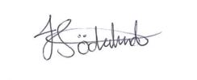
Joanne Soderlund
Returning Officer

