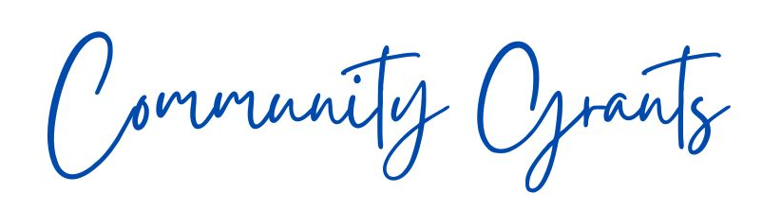

2026/27

Application Form
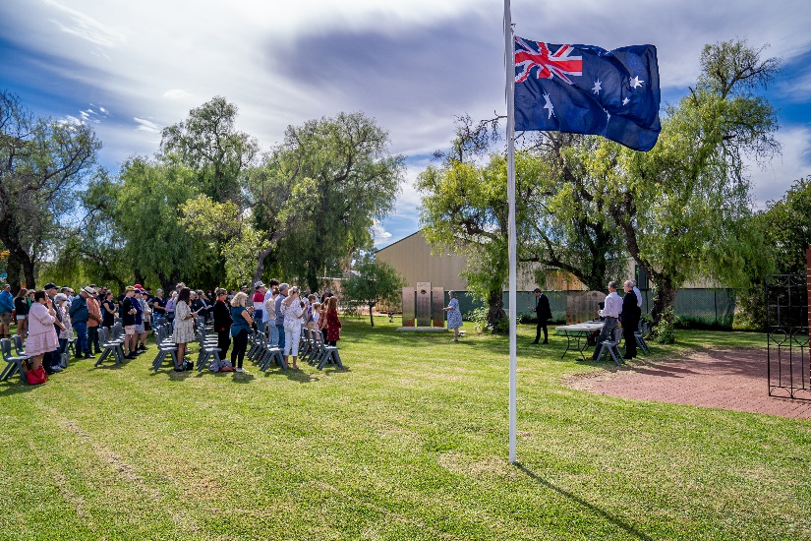

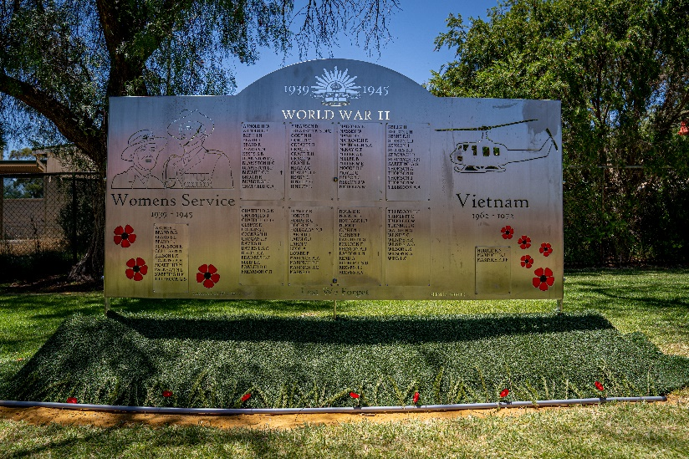


2026 / 2027 COMMUNITY GRANTS

CRITERIA
The Tammin Shire Council invites local sporting and community groups to apply through the 2026 Community Grant round, for funds that may contribute towards a planned capital project within the Shire. Applications will be considered by Council to have funds included in the 2026-2027 financial year budget.
All requests for a contribution will be decided by Council and must demonstrate a thoroughly planned approach. You may be requested to make a presentation to Council prior to considering the request. Council are not likely to consider contributing more than one-third of the total cost of the project.
Successful applicants must provide a financial acquittal of funds including receipts relating to the grant and complete a brief evaluation by 31st May at the completion of the funding period.

APPLICATION REQUIREMENTS
Applications will be considered for funding if the following requirements have been met by the advertised closing date:
- Application form is filled out with as much detail as possible, signed and dated.
- Application aligns with the Shire of Tammin's Strategic Community Plan.
- Evidence that the project will provide additional benefit to the wider community.
- Copy of financial statements attached.
- Copy of Certificate of Incorporation attached (if applicable).
- Copy of all relevant and appropriate supporting documentation (confirmation of additional funding, quotes, plants, letters of support etc.)
APPLICATIONS CLOSE 9am TUESDAY, 5TH MAY 2026

APPLICATION FORM

THE ORGANISATION
Name of Organisation/Club | Click here to enter Organisation/Club name.
Number of Members | Click here to enter member numbers.
Organisation/Club Purpose | Click here to enter who the organisation/club represents and or benefits.
Contact Details | Click here to enter contact name.  Click here to enter phone number.  Click here to enter email and postal address.
Organisation/club ABN  (If no ABN please enter N/A) | Click here to enter ABN.

THE PROJECT
What is the project to be funded? | Click here to enter project name.
Who will the project benefit? | Click here to enter who will receive benefit from the project.
Location of the project? * | Click here to enter address in relation to project.
Owner of the land where project will be located? | Click here to enter land owner name and details.
When will the project be competed? | Click here to enter anticipated project completion date.
* Please be mindful that privately owned assets ie.buildings owned by overarching institutions, will fall outside of the scope for which the Shire would normally provide a contribution.

COSTING
Total cost of the project? | Click here to enter project costs.
Amount of assistance being sought? | Click here to enter amount of financial support being sought.
Additional Funding. | Click here to enter the amount of additional funding your club has sought and the type of funding (e.g. cash, in-kind).
Should there be an outstanding balance who will be responsible for the remaining expenses? | Click here to enter who will be responsible for the remaining project costs.

PREVIOUS ASSISTANCE
Has the organisation/club received any previous funding from the Shire of Tammin? | Click here to enter description of previous funding received.
If yes, in what year and what amount of funding was provided? | Click here to enter amount of funding provided and in what financial year.

SUPPORTING DOCUMENTS
A copy of the organisation/club’s last financial statement is required to accompany the application.
Should you need to attach supporting documents please clearly indicate an attachment number on the application form and the attachment.
Additional documents may be attached if they are relevant to the project proposal.
Applications close 9am Tuesday,5th May 2026.
Applications may be received via mail, email or in person:
Shire of Tammin
1 Donnan Street
PO Box 53,
TAMMIN WA 6409
Should you have any queries in completing the application please contact Community Development Officer on (08) 9637 0300 or via email to cdo@tammin.wa.gov.au.

