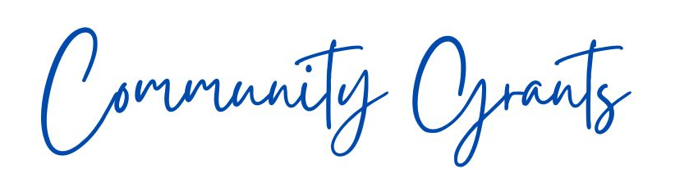
Tammin Progress Inc.

Application Form
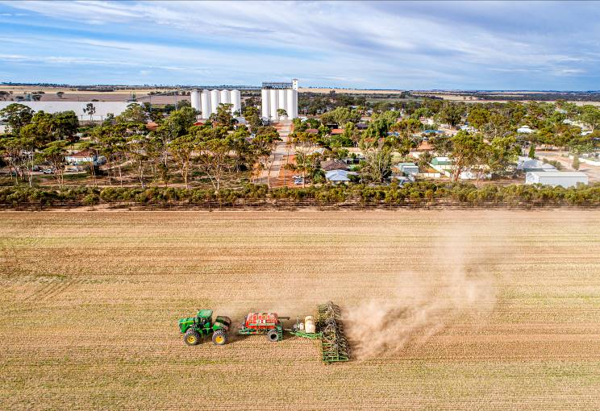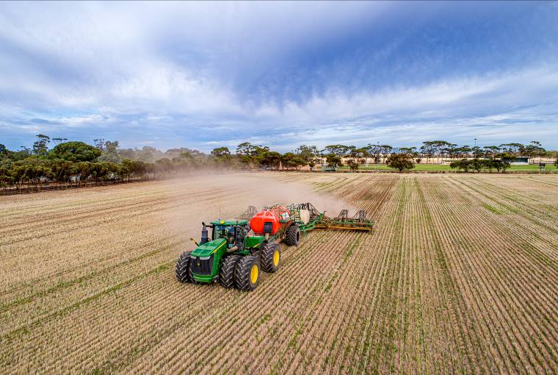
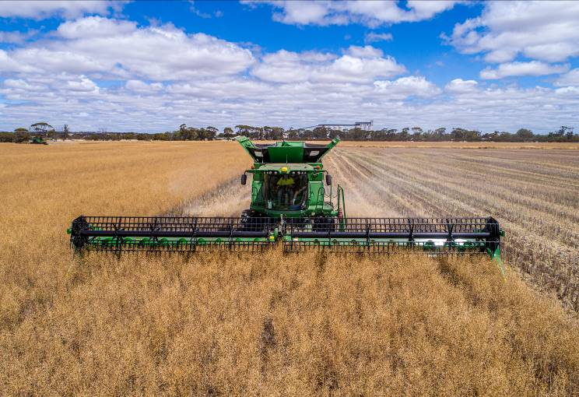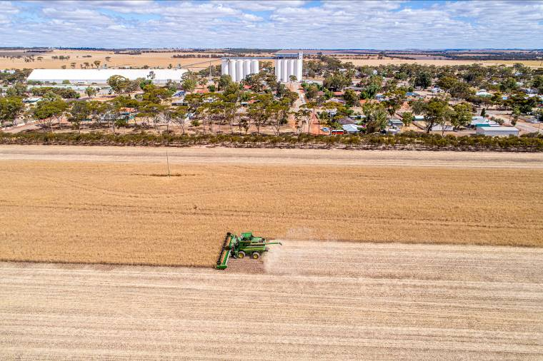

2026 COMMUNITY GRANTS

CRITERIA
The Tammin Progress Inc. invites local sporting and community groups to apply through the 2026 Community Crop Grant round, for funds that may contribute towards a planned capital project within the Shire of Tammin. Applications will be considered by the Tammin Progress Inc. Executive Committee.
All requests for a contribution will be decided by the committee and must demonstrate a thoroughly planned approach. Tammin Progress Inc. are not likely to consider contributing more than one-third of the total cost of the project for Tier 2 projects.
Successful applicants must provide a financial acquittal of funds including receipts relating to the grant on completion of the project.
**There will be two options for funding as per the following:
Tier 1: $3,000 and below
Tier 2: $3,001 and above
Please ensure you tick which option you wish to apply for. Applications that demonstrate appropriate co-contribution and relevant supporting documentation are likely to be considered more favourably.

TAMMIN PROGRESS INC OBJECTIVES

The objects of the Association are:
- To foster social, sporting and community activities;
- To preserve, or improve, for its residents the amenity and environment of the district of Tammin;
- To affiliate with any other association whose objectives are substantially similar to the objects of the association; and
- To manage community fundraising efforts for the association.

APPLICATION REQUIREMENTS
Applications will be considered for funding if the following requirements have been met by the advertised closing date:
- Application form is filled out with as much detail as possible, signed and dated.
- Application aligns with the Tammin Progress Inc. objectives.
- Applications for Tier 2 projects to be accompanied by quotes and supporting documentation.
APPLICATIONS CLOSE 4pm Tuesday, 10th March 2026

APPLICATION FORM

LEVEL OF FUNDING
Please indicate which level of funding your organisation wishes to apply for.
☐ Tier 1: $3,000 and below
☐ Tier 2: $3,001 and above

THE ORGANISATION
Name of Organisation/Club | Click here to enter Organisation/Club name.
Number of Members | Click here to enter member numbers.
Organisation/Club Purpose | Click here to enter who the organisation/club represents and or benefits.
Contact Details | Click here to enter contact name.  Click here to enter phone number.  Click here to enter email and postal address.
Organisation/club ABN  (If no ABN please enter N/A) | Click here to enter ABN.

THE PROJECT
What is the project to be funded? | Click here to enter project name.
Who will the project benefit? | Click here to enter who will receive benefit from the project.
Location of the project? * | Click here to enter address in relation to project.
Owner of the land where project will be located? | Click here to enter land owner name and details.
When will the project be competed? | Click here to enter anticipated project completion date.

COSTING
Total cost of the project? | Click here to enter project costs.
Amount of assistance being sought? | Click here to enter amount of financial support being sought.
Additional Funding. | Click here to enter the amount of additional funding your club has sought and the type of funding (e.g. cash, in-kind).
Should there be an outstanding balance who will be responsible for the remaining expenses? | Click here to enter who will be responsible for the remaining project costs.

Additional documents may be attached if they are relevant to the project proposal.
Applications close 4pm Tuesday, 10th March 2026.
Applications may be received via email to cdo@tammin.wa.gov.au, posted or in person:
Tammin Progress Inc.
C/o Shire of Tammin
1 Donnan Street
PO Box 53,
TAMMIN WA 6409
Should you have any queries in completing the application please contact Community Development Officer, Pixie O’Neill, on (08) 9637 0300 or via email to cdo@tammin.wa.gov.au.

