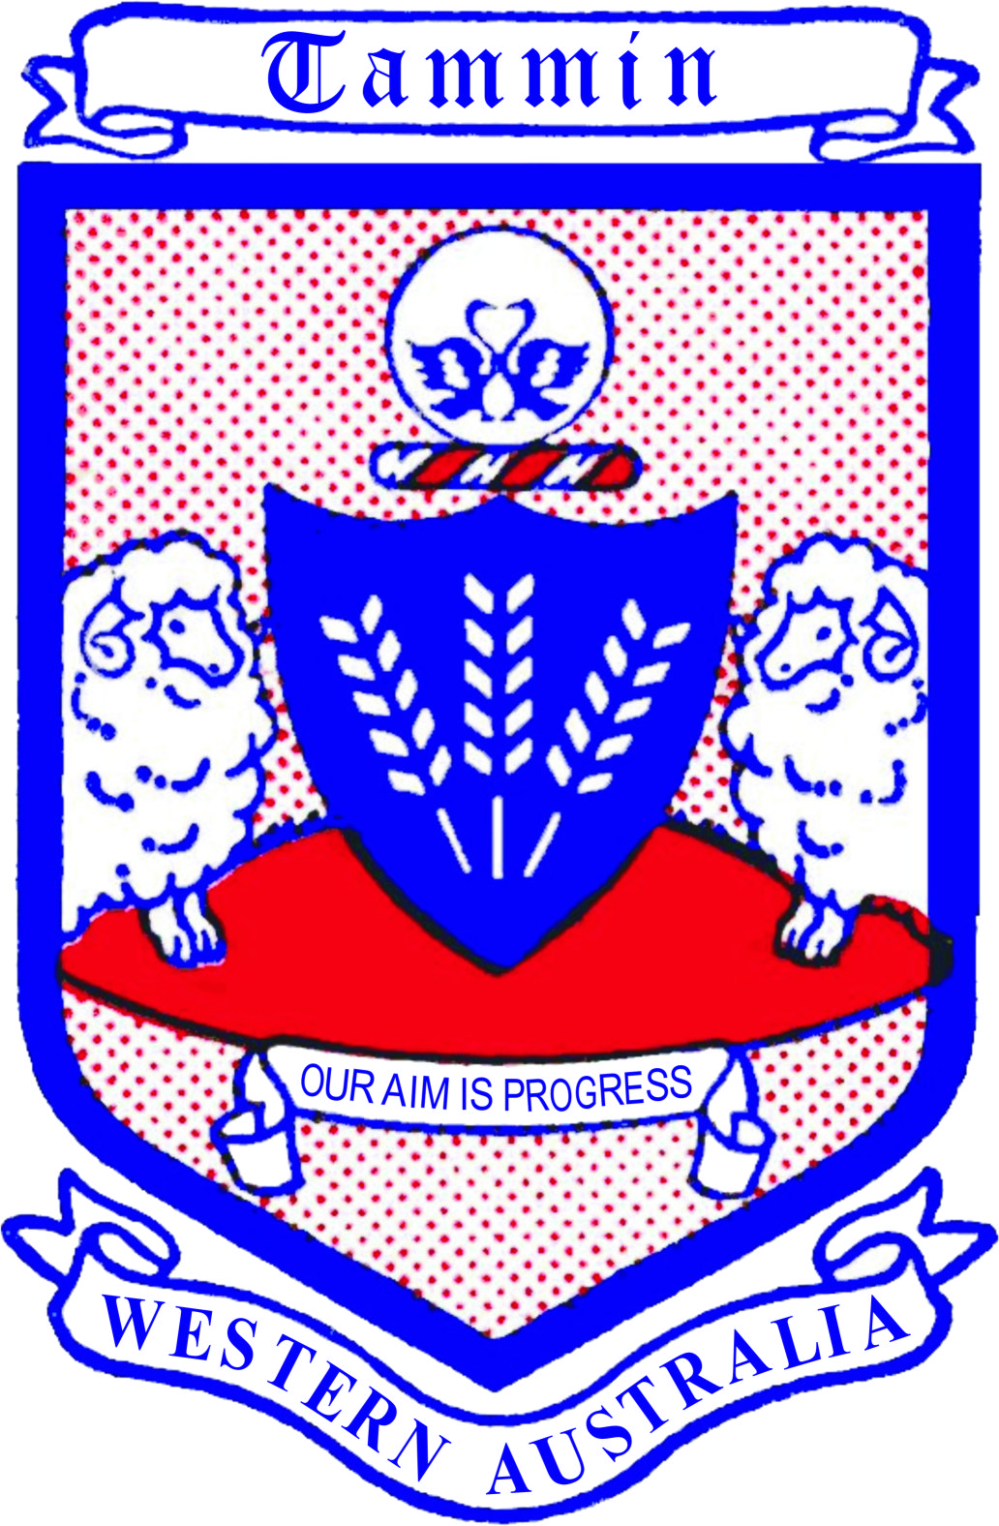

Shire of Tammin

Achievement
Awards Ceremony 2022

Nomination Form

AWARD CATEGORY
(Please tick one appropriate box only – a separate nomination form needs to be completed for each category if nominating a person/group for multiple awards)

2021 Citizen of the Year

2021 Senior Citizen of the Year (over 65)

2021 Youth Citizen of the Year (25 & Under)

2021 Recognition Award (open)

Completed nomination forms must be returned by: Close of Business on Wedensday, 16th February 2022.

“Tammin Achievement Awards – Private & Confidential”
Chief Executive Officer
Shire of Tammin
PO Box 53
TAMMIN WA 6409

Council will consider all nominations at the February Council Meeting.

The Awards will be presented on Friday 18th March 2022. All finalists will be notified by the Shire directly.

SHIRE OF TAMMIN ACHIEVEMENT AWARDS GUIDELINES & CRITERIA

The Tammin Achievement Awards are to acknowledge Tammin residents for their contribution in making a difference to our community.
To recognise those who have achieved success in sporting, cultural and community events. People who put in that extra effort in their contributions and in doing so become role models encouraging and motivating others to step out and set new boundaries for achievement.

GUIDELINES

The recipient will be chosen based on the following guidelines:
- Significant contribution to the local community
- Demonstrated leadership on a community issue resulting in the enhancement of community life
- A significant initiative which has brought about positive change and added value to community life
- Inspiring qualities as a role model for the community

CRITERIA

- Citizen of the Year: A person you believe has delivered outstanding service to the community during the past year.

- Senior Citizen of the Year: A senior person you believe has delivered outstanding service to the community during the past year. To be eligible, the person must be over 65 years of age on March 18th, 2022.

- Youth Citizen of the Year: A young person you believe has delivered outstanding service to the community during the past year. To be eligible, the person must be under 25 years of age on March 18th, 2022.

- Recognition Award: Applies to a community member who has had a significant or outstanding achievement this year in any given field of endeavour.

Name(s) of Person/Group:

Mailing Address:

Contact Telephone Number:
Date of Birth: / /

Please provide as much detail as possible about the person/group that you are nominating – remembering the criteria to the category that you have chosen.

Any other relevant background details (Additional material may be attached if desired):

Other persons who may be contacted for further information about nominee:

Name:
Position:
Address:
Telephone & Email:

Nominator’s details: (the person submitting nomination)

Name:
Address:
Telephone:
Email:
Organisation represented (if any):

Signature/Initial: Date:

All portions of the form must be completed. Incomplete forms will not be accepted.
It is the responsibility of the nominator to seek as much information on the nominee as possible.

